How to upgrade Software on the DL1 / DL2 / DL21

Current software 1.0.6 or above, for version below this ask for instructions
DO NOT ATTEMPT THIS ON SOFTWARE VERSION 1.0.3 or below.
- Download the Skipper Service Software to your PC. http://www.skipper-service.no/skipdoc/skipdoc.php
or direct via
http://www.skipper-service.no/skipdoc/data////Software//SkipperServiceSoftware/SetupProjectServiceSoftware.msi

- Install the software and if required update to the latest version.
- Download the software you require from the web page under folder DL1 –software for CD402 Compact display and JB70 Unit, and/or DL2 Software for screens and JB70 unit
- To load Software into the unit the pc must communicate via TCP/IP V 4 the SKIPPER units follow the standards and have IP addresses in the range 172.16.1.1XX. You need to make your computer also be in this range to do this go to the the network icon in the lower right and click on it.
  - Go to Open Network and sharing centre 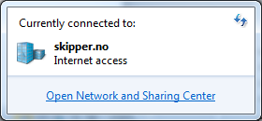
  - Click on Local area Network
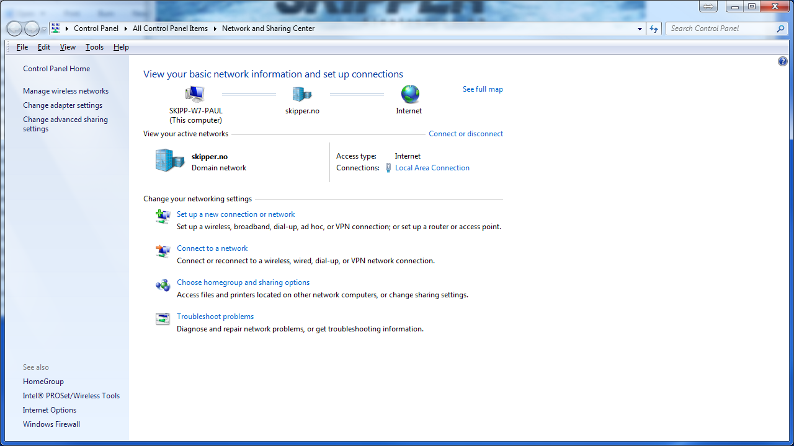
  - Click on properties
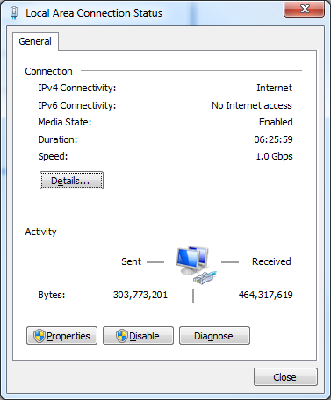
  - Select Internet Protocol Version 4 and click properties
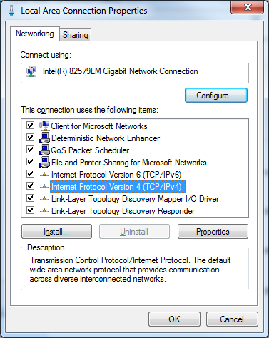
  - Change to Use the following IP address, and enter the correct IP (e.g.172.16.1.90), then click on the Subnet mask, and it will fill in automatically
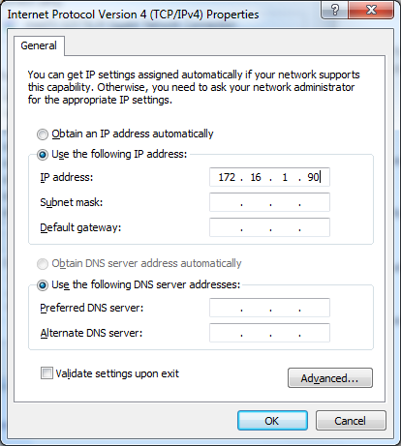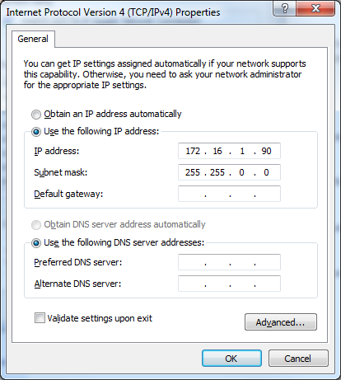
Click OK. (this will have to be returned to ‘Obtain an IP address automatically’ again when you next use the PC in a Normal network.
  - Connect the PC to the network containing the device to be upgraded, or directly to the device.
  - Open the Service software and go to the system APP that you want to upgrade. In this case JB/0D1/CD402 for DL1, or JB70D2 for DL2
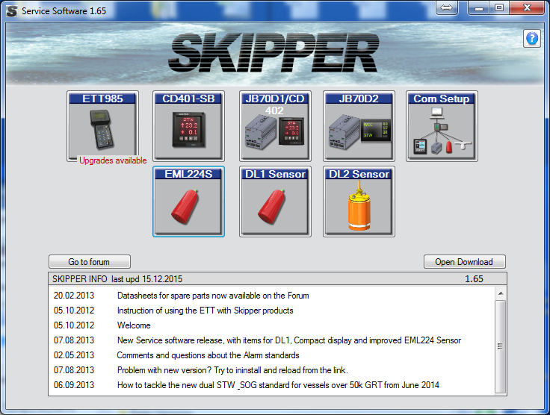
  - In the App, click on the unit to be upgraded ‘Find JB70 Units’ or ‘Find CU-M001’
(in DL2)
You will see the connected units and can then select the software you have downloaded and the system will upgrade.

If the upgrade does not work, try going to the Com setup App and search for the unit. Try going to the link (web page of JB70 D1). If this connects. You have the IP correct. If not , check point ‘e’ again.
If you get a message ‘the selected software is older, check however in some softwares this may be a bug

Try ‘Find system’ again. It should show the new software.

Possible problems during upgrade
- Wrong software version:
  - JB70D1 Needs software SW-M003,
  - CD402 Needs software SW-M001,
  - JB70D2 Needs software SW-M004,
  - CU-M001 Display need software SW-M005
- Connection fails: check static IP or router is in use and that ip is in the same range as the units (default 172.16.1.XXX)
- Cannot ‘find unit’ Check cabling, and power. Check you are on the correct app DL1 or DL2 Check the LAN plugs are in the correct pcbs

